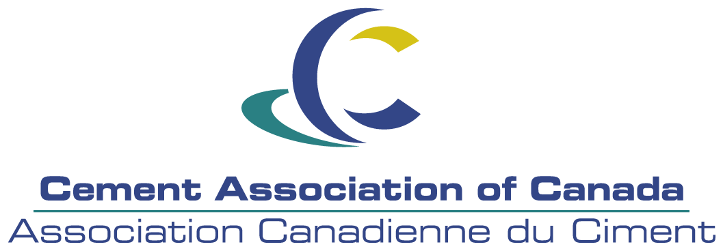

FOR IMMEDIATE RELEASE

Edmonton Builder Wins National Recognition for

Design Excellence and Energy Efficiency in

Residential Construction

EDMONTON, February 21, 2007—Dabrro Homes of Edmonton Alberta is the winner of the Cement Association of Canada's Award for Design Excellence and the Cement Association of Canada's Award for Energy Efficiency.

The Design Excellence award is given to a single-family or multi-family residential project that makes extensive use of concrete building solutions while demonstrating outstanding design and functionality. The Award for Outstanding Energy Efficiency recognizes the unprecedented achievements of ICF homes in energy efficiency. All homes entered in this contest must be built to the demanding R-2000 Standard set by Natural Resources Canada. The award goes to the builder who achieves the lowest calculated energy use.

The awards are two of the four presented at a special Cement Association of Canada Housing Awards pre-conference luncheon ceremony at the 64th National Conference sponsored by the Canadian Home Builders’ Association in Charlevoix, Quebec. Recipients of the 2007 Award for Design Excellence are selected by a panel of independent judges from the Royal Architect Institute of Canada (RAIC) and the Canadian Home Builders’ Association (CHBA).

Not only beautiful but energy efficient too, the Dabrro Homes craftsman-style, in-fill home fits perfectly into its existing neighbourhood. The 1,900 sq. ft bungalow makes extensive use of concrete technologies and products, both inside and out. ICF walls combined with in-floor radiant heating, and an active solar heating system, deliver exceptional energy efficiency, with an EnerGuide rating of 84. Exposed aggregate retaining walls and walkways add to the exterior appeal of the home. Careful construction practices also allowed the preservation of existing mature trees on the building lot.
Insulating Concrete Forms (ICF) are hollow foam blocks or panels connected with plastic ties and filled with reinforced concrete. The left-in-place forms provide a continuous insulation and sound barrier, as well as a backing for drywall on the inside and stucco, lap siding, or brick on the outside. ICF homes generate less construction waste, are quiet and comfortable to live in and require less maintenance.
“Dabrro Homes has demonstrated discerning innovation and foresight,” explains Cement Association of Canada President Pierre Boucher. “Recognizing the impact of rising fuel costs on homeowners, this builder recognizes the important role that concrete can play in minimizing residential energy costs. They have provided hard evidence that insulating concrete forms are the best home building solution for marrying energy efficiency with superb aesthetic appeal.”
The Cement Association of Canada represents 100 percent of Canadian cement producers. The association works with strategic partners to expand the use of cement and concrete in Canada. It provides technical and engineering expertise to the users of concrete and provides a vehicle for its members to participate in public policy development. These efforts seek to increase awareness in the industry’s commitment to vibrant communities, a healthy environment and a competitive economy.
- 30 -

For further information contact:
Sylvie Moncion
Director of Communications
Cement Association of Canada
(613) 236-9471 x 211 (office)
or email: smoncion@cement.ca

